- Payara download:

Link https://payara.fish/downloads/

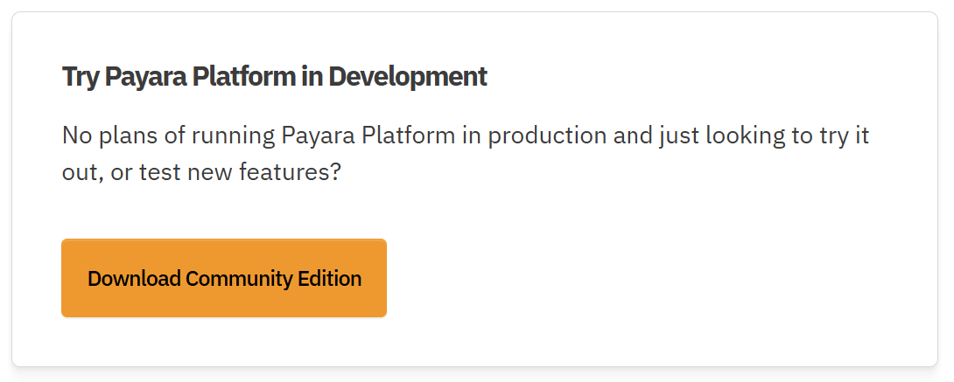



- Tomcat download:

Link https://tomcat.apache.org/download-11.cgi

